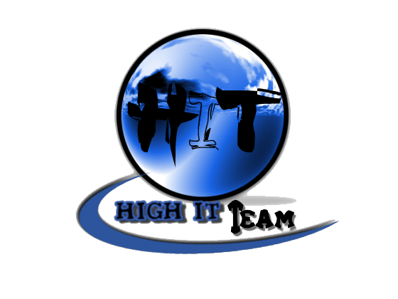
Team Assignment 10
HIT
3/17/2012

Software Measurement and Analysis

Team members: | Members ID
Giang Thị Ha Thanh | T097828
Trần Dũng Đạt | T095716
Nguyễn Vũ Trọng Giang | T096656
Huỳnh Chấn Huy | T096498
Tạ Quang Hiệp | T090363
Nguyễn Trần Hồng Phúc | T095014

Each team analyzes the provided Viking product defect data and submits a report on their findings. In addition, each team lists their recommendations for steps that should be taken to ensure that quality is not an accident for the Viking project based on the defect data (<3 pages total). As input to this exercise you should have access to the following file:
- [Spreadsheet] Viking Project Defect Data.xls
Index

1. Purpose 5
2. Definitions 5
2.1 Risk 5
2.2 Risk Statement 5
2.3 Risk Management 5
2.4 Risk Attributes 5
3. Risks 6
3.1 Cycle 1 6
3.2 Cycle 2 8
4. Identify and Track Risks 10
5. References 10

- Purpose
A risk is an event or condition that, if it occurs, could have a positive or negative effect on a project’s objectives. Risk Management is the process of identifying, assessing, responding to, monitoring, and reporting risks. The purpose of this document is to keep track of the risks that have been identified and prioritized by HIT. Since the HIT team is taking a risk driven approach to the project, the list of these risks that will be used as a guide to strategy and planning.
The Risk Management Plan is created by the project manager in the Planning Phase of the RUP Process and is monitored and updated throughout the project. This document also defines the risk management roles and responsibilities of the HIT Team.
  - Document Maintenance
This document will be reviewed annually and updated as needed, as the project proceeds through each phase of the system development life cycle.
This document contains a revision history log. When changes occur, the document’s revision history log will reflect an updated version number as well as the date, the owner making the change, and change description will be recorded in the revision history log of the document.
- Participants Roles and Responsibilities
This section describes the roles and responsibilities of the Viking staff with regard to the Risk Management Plan. Note that these are roles, not positions or titles. One person may fulfill more than one role. Avoid listing specific names as this will lead to frequent maintenance updates to the plan.
There are various staff resources and stakeholders involved in managing project risks. In some cases, one individual may perform multiple roles in the process.
  - Project Director
The Project Director is involved in monitoring risk action effectiveness and participating in risk escalation. The Project Director also has the responsibility to communicate to certain project stakeholders, on an as needed basis.
  - Project Manager (PM)
The role of the VIKING Project Manager is to write and approve the VIKING Project Risk Management Plan, define the Risk Management process, participate in the Risk Management process, and take ownership of risk mitigation planning and execution
  - Risk Manager/ Plan Manager
The Risk Manager is responsible for leading the risk management effort, sponsoring risk identification activities, facilitating communication throughout the execution of the risk management process, and the statuses assigned to risks and risk activities are current. The Risk Manager is responsible for providing the Project Manager with recommendations and statuses on risk actions.
  - Risk Analyst
The Risk Analyst’s role is to evaluate risks, maintain the Risk Management database, and facilitate communication throughout the execution of the process.
  - Project Stakeholders and Vendors
The role of VIKING Project stakeholders and vendors is to participate in the Risk Management process by providing candidate risk input, and supporting risk mitigation planning and execution activities.
- Viking Project Risk Management
Risk Management provides a disciplined environment to:
- Access continuously any possible errors that could occur (risks)
- Determine which risks are important to deal with
- Implement strategies to deal with those risks

  - Risk Assessment

    - Risk in Cycle 1
Please reference to “Risk List” which shows the prioritized list of risks.
    - Risk Attributes
Evaluating the attributes of a risk involves establishing the current values for:
- Impact: the loss or effect on the project if the risk occurs
- Probability: the likelihood the risk will occur
- Timeframe: the period when action is required in order to mitigate the risk

Impact:
High – Risk that has the potential to greatly impact project cost, project schedule or performance (H): schedule delay more than one month
Middle – Risk that has the potential to slightly impact project cost, project schedule or performance (M): schedule delay between two weeks and one month
Low – Risk that has relatively little impact on cost, schedule or performance (L): schedule delay less than two weeks
Impact | H
Impact | M
Impact | L
Impact |  | L | M | H
 | Probability
Probability:
High (H): 90% +
Middle (M): 51% - 90%
Low (L): 00% - 50%
Risks that fall within the RED and YELLOW zones will have risk response planning which may include both a risk mitigation and a risk contingency plan.
Timeframe:
Near: next 2 weeks
Mid: next 3 weeks
Far: > 1.5 months

  - Risk Control

    - Risk Management Process
The VIKING Project Risk Management Paradigm, depicted in Figure 1, summarizes the Risk Management process for the VIKING Project. This paradigm portrays the high-level process steps of the Risk Management process, which are:
- Step 1 – Identify: Search and locate risks BEFORE they materialize
- Step 2 – Analyze: Process risk data into decision-making information
- Step 3 – Evaluate Risk: Priority Risks by 3 Attributes: Impact, Probability and Timeframe
- Step 4 – Treat Risk
  - Plan: Translate risk information into decisions and actions (mitigations)
  - Implement: Execute decisions and mitigation action plans

Through the process, project team also has to:
- Track/Control
  - Monitor risk indicators and mitigation actions
  - Correct for deviations from planned risk actions
- Communicate: Information and feedback throughout all risk management functions and project organizations

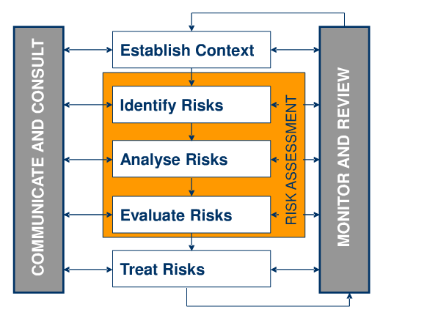
Figure 1: VIKING Project Risk Management Paradigm

    - Risk Solution

Please read The Risk Mitigation Column in file Excel
  - Identify and Track Risks
The level of risk on a project will be tracked, monitored and reported throughout the project lifecycle. HIT team identifies and tracks risks every week through status meetings.

- References
A.J. Dorofee, J.A. Walker, C.J. Alberts, R.P. Higuera, R.L Murphy, and R.C Williams,
Continuous Risk Management Guidebook, Software Engineering Institute, 1996.
PMBOK Guide, 3rd Edition, Section 11 - Project Risk Management
IEEE Standard 1012-1998: IEEE Standard for Software Verification and Validation

